Pattern Recognition Before LeNet5
Before LeNet5, pattern recognition happened using two major modules.
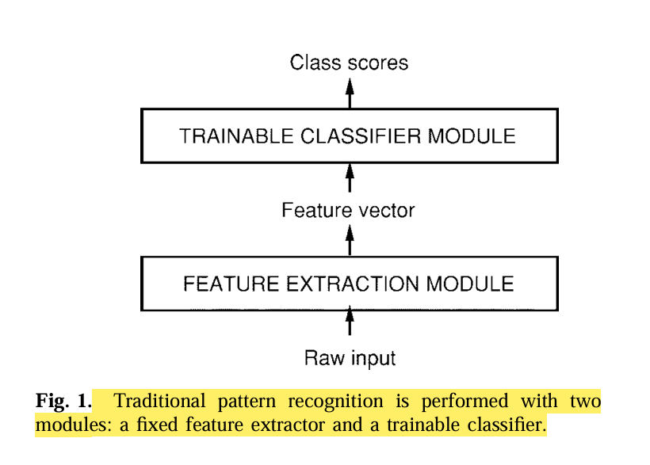

Module 1: Feature Extractor
It converts image into low-dimension vectors.
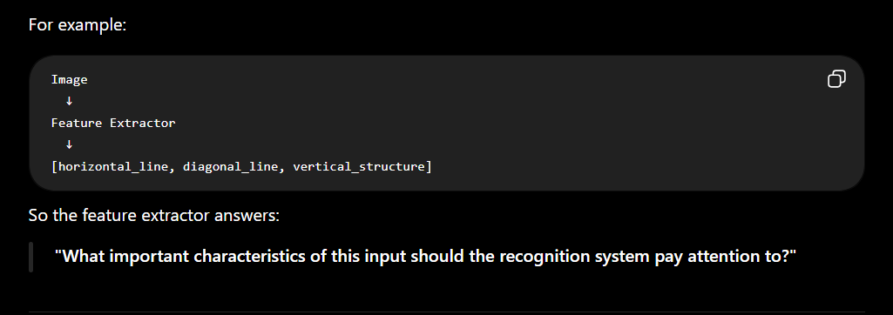
Feature extractor worked on hand crafted features specific to a task (e.g. features in task of digit recognition are different from that of face recognition).

Module 2: Classifier

